General Health

I’m incontinent and wear pads.

I am aware of my incontinence and don’t like
sitting in soiled pads!

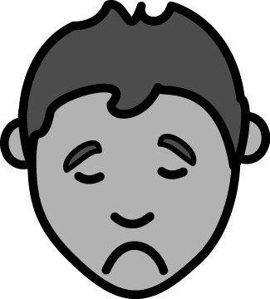

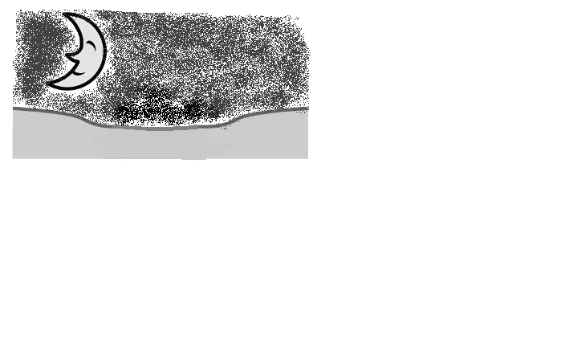
At night

I need 2 pillows under my legs and one between them, when I sleep

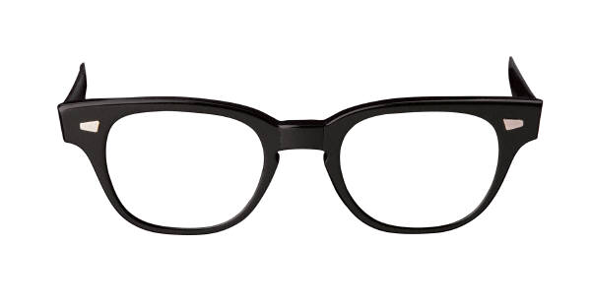

I wear glasses to look at books

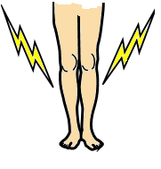
I sometimes have pain in my legs.
Massage will help

